CS 499 Milestone 4 Narrative
Artifact Overview
The artifact I selected is the WeightTracker Android mobile application that I originally created in CS 360 Mobile Architecture and Programming. The original version allowed a user to create an account, log in, set a goal weight, and perform basic create, read, update, and delete operations on weight records stored in SQLite. I returned to this artifact in CS 499 during summer 2026 and redesigned it as a Cardiac Rehab Progress Tracker. The Milestone Two and Milestone Three enhancements expanded its software structure, validation, dashboard, rehab-session workflow, and progress-analysis logic. Milestone Four builds on that working version by concentrating on the way its information is stored, connected, protected, and migrated.
I selected this artifact because it shows a clear progression from a small course project into a more complete healthcare-focused application. It also connects directly to my career goal of moving from cardiac rehab into healthcare software. In my current work, accurate documentation and consistent progress data are important parts of the workflow. This made the database a meaningful area to improve instead of treating it as a background feature that only exists to make the interface work.

Database Enhancement and Skills Demonstrated
Before this enhancement, the application already used SQLite, but the design still reflected the limits of the original WeightTracker project. Goal weight was stored directly on the user row, passwords were stored as plain text, and the rehab-session and weight tables did not have enforced foreign-key relationships. The earlier upgrade logic had improved from dropping every table, but the database still needed a structure that better matched the cardiac rehab use case.
The enhanced database uses version four of the schema and separates the information into users, goals, rehab sessions, and weight entries. The users table now stores a username, salted password hash, display name, age, and profile-created date. Goal weight is stored in the goals table, which allows the design to support additional goal types later without adding another column to the user record. Rehab measurements remain in the rehab_sessions table, while weight is stored as a progress entry that can be linked to a session. This reduces unnecessary coupling between the different types of information and makes the purpose of each table clearer.
I added foreign keys with cascade behavior, a composite relationship that prevents a session weight from being associated with a different user, SQL CHECK constraints for measurement ranges and date formats, and indexes based on the user and date fields used by the dashboard. The repository now saves a rehab session and its linked weight record inside one transaction. If either insert fails, neither record is committed. Updates follow the same pattern, and a session deletion automatically removes its linked weight entry. Parameterized selections continue to scope updates and deletes to the authenticated user.
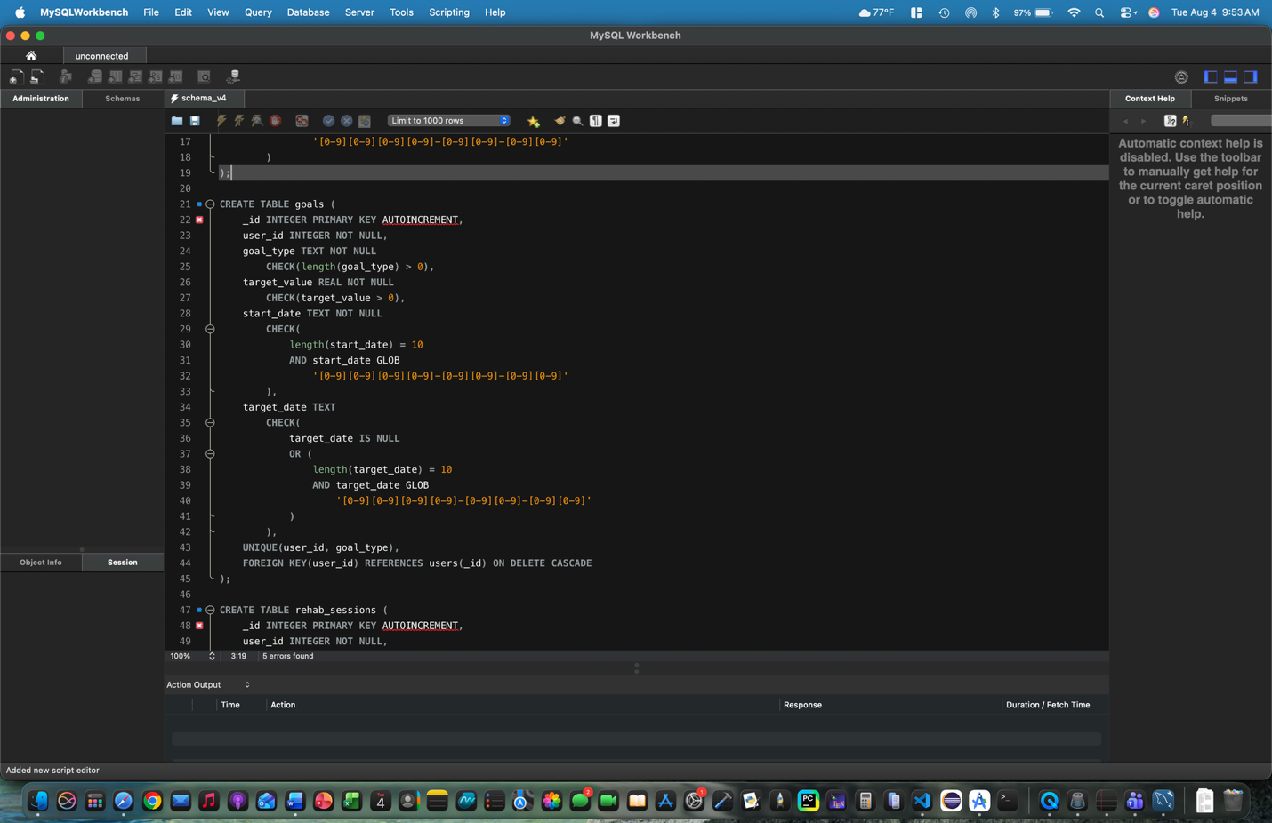
Figure 1. The version-four schema uses normalized tables, constraints, indexes, and cascading foreign-key relationships to protect data integrity.
The security-related changes were also important. New and migrated passwords are stored as salted PBKDF2-HMAC-SHA256 hashes instead of reversible text, local application backup is disabled, and the internal activities are explicitly marked as not exported. I also added validation for new account fields and standardized supported legacy dates into ISO YYYY-MM-DD format before saving them. These choices do not turn the academic application into a production medical-record system, but they demonstrate the security and data-integrity mindset that healthcare software requires.
To make the work easier to review, the enhanced artifact includes a readable schema_v4.sql file, unit tests for password hashing, account validation, and date normalization, and Android instrumentation tests for migration, foreign-key enforcement, and cascade deletion. These additions show the database design in both the working product and the supporting technical documentation.

Alignment With Course Outcomes
Outcome 1
I made progress toward this outcome by organizing the stored information so that the dashboard and future healthcare stakeholders can rely on consistent relationships and progress records. The database enhancement alone is not a collaborative environment, but its documented schema and predictable data model make the artifact easier for another developer or reviewer to understand and extend. The larger ePortfolio, code review, and feedback process provide the stronger collaboration component.
Outcome 2
The narrative, schema reference, README, code comments, and user-facing validation messages communicate the purpose of the enhancement to different audiences. A technical reviewer can inspect the keys, constraints, migration, and tests, while a nontechnical reviewer can see how those decisions improve reliability and privacy in the working application.
Outcome 3
The database structure supports the algorithms from Milestone Three by providing consistent ISO dates and indexed user/date lookups before records are loaded into the in-memory analysis layer. I also evaluated trade-offs between keeping the session model convenient for the dashboard and normalizing weight into its own table. The repository join preserves the existing object model while the transaction keeps the two database records synchronized.
Outcome 4
This is one of the strongest outcomes demonstrated by the enhancement. I used SQLite schema design, Android database APIs, a repository layer, transactions, joins, indexes, migration logic, and automated tests to build a database solution that delivers more value than the original two-table design.
Outcome 5
The enhanced artifact anticipates several avoidable data and security problems. Passwords are no longer stored in plain text, SQL values are parameterized, related records require valid owners, invalid measurements can be rejected at both the application and database levels, and backup/export exposure is reduced. All sample information remains fictional, which is appropriate for the scope of the portfolio project.

Reflection on the Enhancement Process
The most important thing I learned is that improving a database is not only a matter of adding more tables. The difficult part is deciding where each piece of information belongs, how the records should relate to one another, and what should happen when one operation succeeds but another fails. Separating session measurements from weight entries was useful for normalization, but the application still needed one RehabSession object for its analysis and dashboard. Solving that issue with a repository join helped me understand how the database model and application model can be different without making the user-interface code more complicated.
The version 3-to-4 migration was the largest challenge. Dropping and recreating tables would have been easier, but it would also erase the exact records the application is supposed to track. The migration instead renames the legacy tables, creates the normalized schema, copies users while hashing their existing passwords, converts goal weights into goal records, standardizes supported date formats, recreates session relationships, and removes the legacy tables only after the copy is complete. The upgrade runs inside the database transaction, so an unexpected failure rolls back the change rather than leaving a partially migrated database.
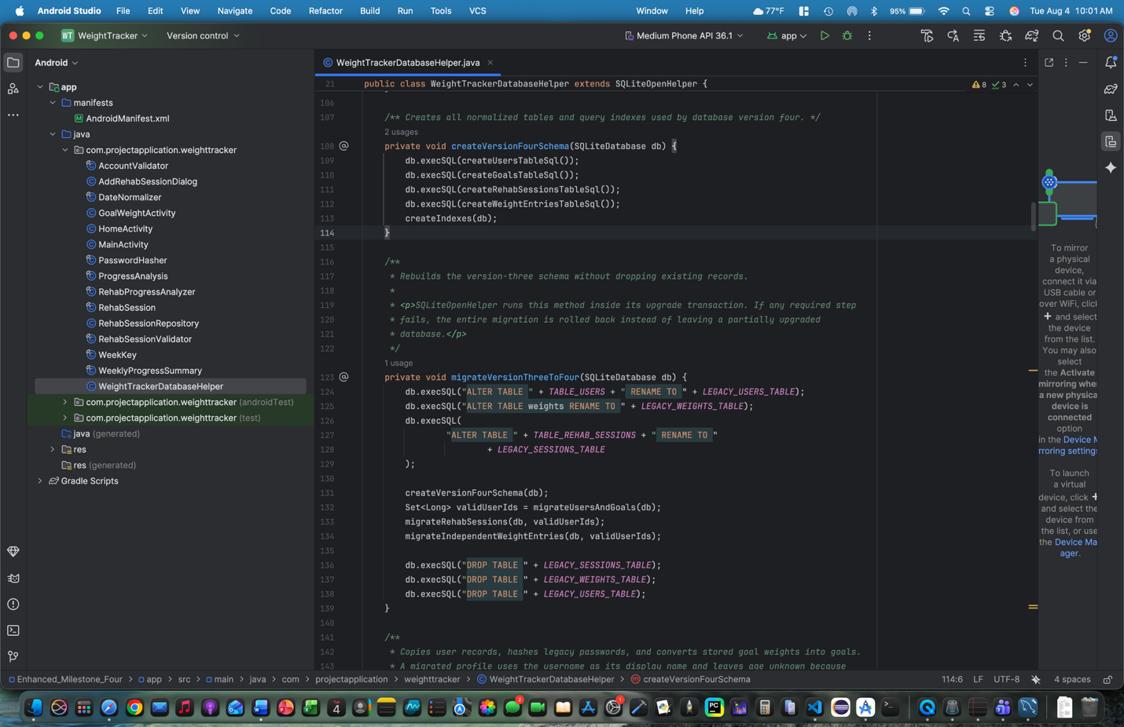
Figure 2. The version 3-to-4 migration preserves existing records while transforming credentials, goals, dates, and table relationships for the new schema.
Another challenge was handling information that the original application never collected. Older users do not have a real display name or age value. Instead of inventing personal information, the migration uses the existing username as the display name and leaves age unknown. New accounts collect and validate both fields. This was a useful reminder that data migration requires decisions about missing information, not just decisions about SQL syntax.
Overall, the enhancement met the database plan from Module One and also addressed the security and migration concerns identified in my code review. The strongest growth for me was learning to think about integrity across the full lifecycle of a record: creation, retrieval, update, deletion, and upgrade. The finished artifact now provides a much stronger demonstration of database design, secure credential storage, testing, and healthcare-focused software development.

